Theme and content requirements based on http://r5.template.expertagent.co.uk
This document outlines the standard set of content and imagery required from you to populate the standard 9 website navigation pages. Please work through each section below to gather the necessary content.
*While preparing written content please pay attention to key words and phrases in relation to search engine optimisation. More information on this can be found in our guide here: https://www.zooplawebsites.co.uk/guides/seo
Home page
- Logo
Please provide a high-resolution copy of your logo in either of these formats:
Formats: .jpeg, .png, .eps.
- Social Media URLs
Please provide the direct web links to your social media pages i.e., Facebook and Twitter pages.
- Email address and Telephone number
Please provide the email address and telephone number you would like to appear in the top section of the website.
- Slideshow
A large photo is required for the banner section of the home page. The banner section can either be a static single photo, or an animated slideshow. If a slideshow is the preferred choice, please provide approx. 5x photos instead.
Format: .jpeg
Dimensions: A large high-resolution photo which suits a landscape/panoramic proportion. We find something around a 1900px (w) by 500px (h) works quite well.

*Please note: The banner photo needs to compliment a landscape or ‘letterbox’ orientation, to match the available space and how the images are cropped to fit. For example, a portrait photo of a skyscraper or church will not fit well, whereas a landscape rooftop scene will work better.
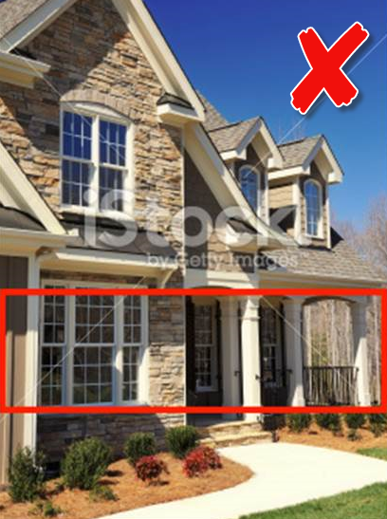
The below example demonstrates a good choice of banner photo, versus a bad choice. It also shows how the image will be cropped to fit into theme 1:

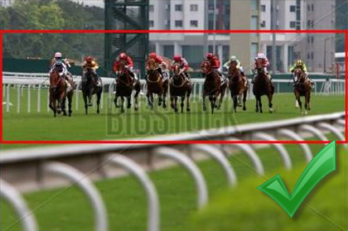

- Welcome Text (approx. 100 Words)
e.g.,
“Welcome to Baxter’s Estate Agents, Bath, Somerset
Baxter’s Estate Agents specialise in residential sales and lettings, and commercial and auction properties. Our experienced team can advise you on just about everything from decor to financial advice, we have it covered!
With over 150 years combined experience, and local knowledge covering Bath, Frome, Warminster, and surrounding areas in Southwest England, you can be comfortable leaving the task of buying or selling your property in our hands. Please browse through our website to see exactly what we can offer.”
- Call to Action #1 – approx. 20 Words
e.g.
“FREE VALUATION
Take advantage of a free no obligation valuation and our competitive selling fee of 1.5% + VAT and experience the difference for yourself!”

- Call to Action #2 – approx. 20 Words
e.g.
“REGISTER WITH US
Want to keep up to date with properties you might be interested in? Register with us to receive regular property updates”

- Call to Action #3 – approx. 20 Words
e.g.
“MORTGAGES
We have a dedicated financial team in to assist with any mortgage advice you may need! Click here for more details.”

- Featured Property
Selected within your property software - no text content required.
- Latest Properties
Automated within your property software - no text content required.
- Testimonials
Please provide up to 10 testimonials for placement in the animated slider.

Word count: Approx. 70 words each review.

- Affiliate Logos
Please confirm which affiliate logos you would like displayed in the footer i.e. Rightmove, Zoopla and so on.

- Savings Calculator
Please confirm your fixed fees, or we can remove this if not required.
Locations
Please provide a list of the locations you will cover. These must be either a Town or City name. Postcodes are not compatible with the data feed.
Latest Properties Page
Automated within your property software - no text content required.
For Sale Page
Powered by your property software - no text content required.
To Let
Powered by your property software - no text content required.
About Us Page
Please provide text content about your business and an office or team photo to be displayed alongside the text if you require.
Word Count: up to 1 side of A4
Office Photo: jpeg. No less than 600 pixels wide
Staff Profiles: If you wish for these to be included on this page, please provide the following:
Staff photo: jpeg. No less than 300 pixels wide.
Job title
Description – Approx. 80 words
Telephone
Email
LinkedIn URL (or similar) – If required
* Up to 4 staff profiles are included as standard. Any additional requirements will incur an additional charge to setup.
Our Services Page
Please provide text content related to the services you cover.
Services Text Word Count: up to 1 side of A4
Valuation Page
The valuation form contains a standard set of fields. We can add or remove any fields which are not relevant to your business.
Please provide text content to be placed above the form if required.
Register Page
Please provide text content to be placed above the form if required.
Contact Us Page
The contact us page displays a map feature plotting your branch, contact information relating to each of your branches and an enquiry form. Please provide the below information for each branch that you have:
- Branch Contact Information
Baxters Estate Agents
57 Vallis Rd
Frome
Somerset
BA11 3EG

Telephone: 01225 303500
Email: zwfulfilment@zoopla.co.uk
Opening Hours: Mon – Fri: 9am – 5.30pm
Office Photo: jpeg. No less than 600 pixels wide

- Statutory Company Information
You are required to provide certain statutory information relating to your business such as the registered company number, address, and VAT number, if applicable.

Other Required Information
- Please provide a Privacy Policy and any other required documentation for inclusion in your website in a .pdf format, which will be linked to from the website footer and adjacent to any forms.
- Should you choose to implement any 3rd party features into the website that are not supplied by us, please ensure that an updated cookie policy is provided to accommodate any additional cookies they may drop into the site.
Extra Optional Features
The following extra features are available for integration in your website:
Zoopla Valuation Tool
Add our online automated valuation tool to your website to generate more leads and increase revenue.
Driving traffic to your website is great but getting visitors to leave their details is hard. Typical conversion rates are below 1%.
Increase your chance of converting them by offering an instant valuation when they arrive. Offer vendors and landlords something they want you’ll get richer data in return.
If you are interested in this feature, please submit an enquiry here and a member of the team will be in touch.
Blog Feature
Keep your customers up to date and help improve seo and exposure to your website at the same time.
We have an integrated blog feature which can be included for a one-off setup fee of £80+vat. The feature will allow you to add/edit/delete blog posts, and upload images via a front-end editor access. It will also allow you to apply a meta description and keywords to each post, to benefit search engine optimisation. Login details for accessing the page are provided after website sign off.
An example of the blog page on your chosen theme can be viewed here - http://r5.template.expertagent.co.uk/blog
If you are interested in having a blog page on the website, please let us know.
Area Pages
Extra ‘area’ landing pages can prove helpful for search engine optimisation, based on the areas your business covers. They can provide useful information for your customers, such as general information about the town, property prices, facilities etc, and could also show a selection of properties. They provide useful for SEO because they will contain important keywords relevant to your business and a particular area and help direct traffic back to your website.
If you are interested in displaying area pages on your website, please let us know and we can provide a quotation and confirmation of what the page will contain.
PropertyFile
If you are an Alto or Jupix customer, you may wish to enable PropertyFile functionality on your new website. Please refer to the following guides on how this can be configured for each platform:
Alto customers – https://support.altosoftware.co.uk/hc/en-gb/sections/360002931277-PropertyFile-Overview-Activation-and-Configuration
Jupix customers – https://support.jupix.com/hc/en-gb/categories/360002158018-PropertyFile-Ravensworth-other-services
Once the tool is fully enabled in your software you will need to email us your unique PropertyFile Key and URL before it can appear on the website.
Have Other Questions?
Please refer to our frequently asked questions
Please visit out useful FAQs guide where we have covered most common topics relating to the product you have ordered, what is included, process and what you need to supply - https://www.zooplawebsites.co.uk/guides/website-faqs
Need to speak to us?
Email is our preferred method of contact and during the initial Fulfilment of the new website you should reply on the back of our outbound communication to you. This is so we can maintain a clear admin trail of all conversations in our system, which we can easily refer back to, and easily exchange and save files which relate to the build of the website.
Should you need to discuss anything more complex over the phone the team can be contacted on 01225 667435.

